Walmart 02 Seasonal Space

A report submitted in partial fulfillment of the requirements for
DASC 48902/489H2 Data Science Practicum I
and
DASC 49903/499H3 Data Science Practicum II

By
Team 6, Stella Shipman, Conrad Haslauer, Cody Uhl
Data Science Program
University of Arkansas
Spring 2026

Signature Page
Dr. Karl D. Schubert
schubert@uark.edu
Professor of Practice
Associate Director, Data Science Program
Honors Director, Data Science Program

Christopher Rainey
Christopher.Rainey@walmart.com
Senior Manager, Advanced Analytics
Walmart

Thomas Carter
Thomas.Carter@walmart.com
Senior Manager, Assortment Analytics
Walmart

Abstract
Walmart stores must balance limited retail space between seasonal merchandise and year-round categories to ensure customers can consistently find the products they expect while maximizing fixture efficiency. Seasonal items can drive strong sales during peak periods, but over-allocation may reduce space available for core categories that require consistent year-round placement. This practicum project focuses on determining how fixture space should be allocated to seasonal and year-round product categories within the men’s and women’s fashion departments across Walmart stores, using fixture count as the primary measure of retail space.
The project began with extensive data preparation and exploratory analysis of two years of weekly merchandising data from approximately 1,200 stores across 35 states. These datasets included sales, inventory, category labels, and fixture allocation information for men’s and women’s apparel departments. Early analysis revealed significant data quality challenges, including missing fixture values, structural shifts in merchandising data, and limitations in Walmart’s existing seasonal category labels that did not accurately reflect actual allocation behavior.
To address this, the team developed a modeling framework that combines descriptive, predictive, and prescriptive analytics. A subcategory-level classification framework was created using fixture presence and volatility to better identify stable, moderate, and seasonal allocation patterns across stores. In parallel, a machine-learning demand model was developed to estimate unconstrained customer demand at the store × subcategory × week level, helping distinguish true customer demand from inventory-limited sales performance.
These outputs were then integrated into a linear optimization model that allocates stable and flexible fixture space across subcategories while respecting total store capacity, operational constraints, and department-level allocation limits. The objective was to prioritize high-demand categories while maintaining sufficient stable space for core year-round products and preserving flexibility for seasonal demand shifts.
Results showed that fixture allocation is highly concentrated among a relatively small number of high-demand subcategories and that effective allocation strategies vary significantly by department. Men’s departments were more heavily dominated by stable fixture allocation, while women’s departments relied more on flexible space to respond to trend-driven demand changes. Flexible fixtures also demonstrated higher utilization across stores. These findings support a more scalable, data-driven approach to retail space planning and provide practical recommendations for improving fixture allocation decisions across Walmart’s fashion departments.
Table of Contents
Title Page
- Abstract
- Introduction
- Literature Review
- Methodology
3.1 Understand the Problem
3.2 Acquiring the Data
3.3 Understand the Data
3.4 Data Preparation
3.5 Exploratory Data Analysis (EDA)
3.5.1 Seasonality EDA
3.5.2 Fixture mix analysis
3.5.3 Null Data Analysis and Handling Decisions
3.6 Model Implementation
3.6.1 Subcategory Classification
3.6.2 Demand Score Model
3.6.3 Optimization Model
3.6.4 Model Interpretation
3.7 Tools and Technologies
4. Optimization Results & Insights
4.1 Capacity Utilization
4.2 Allocation Concentration
4.3 Department-Level Differences
4.4 Top Subcategory Allocations
4.5 Example Store-Week Allocation
5. Discussion & Interpretation
6. Business Impact & Recommendations
7. Future Work & Retrospective
8. Conclusion
9. References Cited
10. Appendix

Walmart 02 – Seasonal Space Allocation

Introduction
Walmart’s Fashion division relies on effective space planning to balance seasonal merchandise with year-round categories while ensuring customers can consistently find the products they expect. Seasonal items can drive strong sales during peak periods, but allocating too much space to them risks reducing visibility and performance of core categories that require consistent placement. Conversely, underutilized space during off-season periods often defaults to clearance, which may not represent the most productive use of available fixtures.
Currently, space allocation decisions in fashion departments are often guided by merchandising strategy and business intuition rather than a standardized, data-driven framework. Fixture adjustments may be made to grow specific categories or respond to short-term trends, but these decisions do not always follow clear optimization guidelines. Additionally, Walmart’s existing seasonal category labels do not always reflect true fixture allocation behavior at the store level, creating inconsistencies in how seasonal versus year-round space is managed.
Our practicum project addresses this challenge by developing a systematic framework to improve fixture-allocation decisions in men’s and women’s fashion departments. Using fixture count as the primary measure of retail space, the project combines subcategory-level classification, demand modeling, and optimization to determine how stable and flexible space should be allocated across stores. This approach accounts for store-level variation, seasonal demand patterns, and operational constraints, with the goal of improving fixture utilization, increasing sales productivity, and supporting more consistent merchandising decisions.
While the initial scope focuses on a subset of stores within Walmart’s cold-weather cluster, the methodology is designed for scalability across Walmart’s broader store network. Success is evaluated through improved fixture utilization, stronger alignment between demand and allocation decisions, and more effective use of both stable and flexible space throughout the year. The primary audience includes Assortment Analytics employees, modular planning teams, and business stakeholders seeking to optimize retail space planning in fashion departments.
Practicum Technical Contribution Objectives
Our project focuses on building a scalable, data-driven framework that helps Walmart make more informed decisions about fixture space allocation across men's and women's fashion departments. Rather than relying solely on existing seasonal labels or intuition-based merchandising decisions, the goal is to better align retail space with customer demand and operational fixture behavior. From a technical standpoint, our main objectives are:
- Handle data challenges: Clean, validate, and organize large-scale merchandising datasets with millions of rows, missing fixture values, and structural inconsistencies, making them suitable for analysis and modeling.
- Develop subcategory classifications: Create a reliable, interpretable framework to classify store x subcategory combinations into stable, moderate, and seasonal groups using fixture presence and volatility rather than relying on existing category labels alone.
- Build a demand model: Develop a predictive model that estimates unconstrained customer demand at the store x subcategory x week level, helping distinguish true customer demand from sales limited by low inventory availability.
- Develop an optimization model: Use classification outputs and predicted demand scores to optimize how stable and flexible fixture space should be allocated across subcategories while respecting store-level capacity and operational constraints.
- Deliver usable outputs and code: Produce well-documented, adaptable code and store-level allocation outputs that Walmart teams can use for ongoing analysis, decision-making, and future model refinement.
These objectives support the transition from broad, intuition-based fixture planning toward a more consistent and scalable framework for retail space optimization.

Literature Review

The scope of our project focuses on retail fixture space optimization and how fixture allocation changes throughout seasonal demand shifts. From our research on this niche problem, we found that this exact project may not have been done before. However, there are many published studies on similar retail optimization problems within different scopes, particularly in fashion and merchandising. This research is still highly useful. Much of our literature review examined related projects and identified methods and insights that could be applied to our own methodology.

The key insights from our literature review helped guide both our model design and its potential implementation within Walmart’s existing framework. The main difference between our project and most existing research is the use of fixture-level allocation versus SKU-level shelf-space optimization. Many existing models, such as those discussed in article 1.5, focus on optimizing individual products or SKUs. SKU-level models are too granular for our context. Our project is not focused on optimizing product arrangement on a shelf, but rather on optimizing the overall fixture allocation and floor plan within a department. However, these studies still provided valuable methodologies that can be adapted from the SKU level to the fixture-block level.

Our approach centers on a capacity-constrained fixture allocation model, while avoiding highly complex planogram-level metaheuristic searches to ensure more realistic deployment. Success for our model is measured through improved sales productivity and stronger returns on seasonal fixture space. The literature also highlighted the importance of demand behavior and allocation efficiency, which influenced our development of features related to demand patterns and fixture utilization across stores and departments.

The most valuable insight we gained from the literature review is that implementing models like the one we are building is often more difficult in practice than in theory. While data-driven optimization models can outperform intuition-based decision-making, real-world retail constraints such as branding requirements, departmental planning, and operational standards make these models more difficult to apply effectively. As we move into the modeling portion of the project, we must evaluate our outputs with a level of skepticism. Can the results of our model be implemented realistically without conflicting with Walmart’s existing operational standards? This question should remain at the forefront when presenting the final deliverable.

2.1 Fixture-Level Retail Space Elasticity
Retail space allocation has been extensively analyzed using the concept of space elasticity, which examines how increases in product-facing space or fixture presence affect sales by improving visibility and boosting shopper engagement. Schaal and Hübner (2018) studied cross-space elasticity in shelf-space planning and found that although cross-item interactions occur, the main factor driving retail space performance is direct space elasticity rather than substitution effects between SKUs. They also suggest that modeling SKU-level interdependencies adds significant complexity with limited added value, since profitability shifts are more heavily influenced by the amount of space allocated, category volatility, and margin profiles than by detailed product-to-product interactions (Schaal & Hübner, 2018). Based on their research, our project deliberately focuses on fixture-level allocation strategies rather than SKU-level substitution modeling, emphasizing the incremental space productivity of seasonal fixtures relative to core merchandise blocks.

2.2 Practical Constraints and Applied Optimization Gaps in Retail Space Planning
Düsterhöft and Hübner (2023) highlight that although academic models for retail shelf-space optimization have become more sophisticated, real-world adoption remains limited due to trade-offs in abstraction, issues with data granularity, and the gap between operational planners and mathematical models. They argue that retail environments need models that strike a balance between analytical rigor and practical simplicity, noting that many optimization frameworks assume ideal conditions, such as static assortments and perfectly measured elasticities, which are rarely found in practice (Düsterhöft & Hübner, 2023). Their work stresses that retailers value interpretability and configurability over pure theoretical optimality, especially when seasonal resets are carried out by visual merchandising teams rather than data science specialists. Consistent with this perspective, our practicum intentionally avoids micro-interactions at the SKU level and instead concentrates on fixture-level allocation across departments, an appropriate level of detail that supports planning while remaining operationally viable. Following Düsterhöft and Hübner’s advice that models should align with retailer decision-making capacity, we implement a capacity-constrained fixture allocation model, omitting high-dimensional planogram-level metaheuristic searches to ensure realistic deployment.

2.3 Seasonal Merchandise Planning as a Constrained Optimization Problem
Smith, Agrawal, and McIntyre (1998) introduce one of the earliest discrete optimization models for seasonal merchandise planning, showing that retail decision-making during high-variability periods, such as seasonal changeovers, requires structured allocation within resource limits, including markdown budgets, advertising slots, and promotional frequency. Their research demonstrates that seasonal planning is not a continuous process but a capacity-limited episodic optimization task, driven by fixed calendar windows and limited display resources (Smith et al., 1998). While their model centers on SKU- and promotion-level scheduling, the core idea of maximizing marginal return on constrained seasonal assets directly influences our fixture allocation approach. We follow the principle that each additional seasonal resource (e.g., fixture segment, markdown slot) should be evaluated based on its incremental margin contribution. However, unlike Smith et al., we do not optimize promotional calendars or markdown timing, as these are outside the scope of our fixture capacity analysis. Instead, their work supports our framing of fixture space as a seasonal capital allocation problem.

2.4 Fixture Space as Constrained Capacity: Inventory Optimization Perspective
Ali, Rabiu, and Ismail (2025) conceptualize inventory positioning as a constrained capacity decision, arguing that physical limitations, such as warehouse space, budget, or display area, act as resource channels that need optimization under demand uncertainty. Their inventory optimization framework highlights the importance of assessing trade-offs between over-allocation and underutilization of limited capacity, noting that excess allocation to one category naturally reduces potential benefits elsewhere (Ali et al., 2025). Applying this capacity concept to our retail context, we reinterpret fixture space as a strategic resource like inventory capacity, where seasonal displays and core categories compete for limited physical exposure. This theoretical approach supports our decision to frame the issue in terms of marginal fixture productivity and regression-informed allocation limits rather than unconstrained visual merchandising heuristics. However, unlike Ali et al., we do not include reorder dynamics or safety stock models, as fixture space cannot be replenished dynamically; it must be assigned in discrete seasonal blocks, making capacity allocation (not flow control) our focus.

2.5 Optimization Techniques in Shelf-Space Allocation and Their Relevance
Lim, Rodrigues, and Zhang (2004) and Bianchi de Aguiar (2015) demonstrate that metaheuristic and hybrid mathematical programming approaches can produce near-optimal shelf-space arrangements by considering SKU adjacency rules, facings, and merchandising guidelines. These studies confirm that advanced combinatorial optimization can enhance planogram efficiency, especially when combined with local search refinements (Lim et al., 2004; Bianchi de Aguiar, 2015). However, both also recognize that computational complexity and parameter estimation become prohibitive as real-world constraints increase, prompting many retailers to reject mathematically optimal solutions in favor of simpler, more understandable allocation methods. Unlike these high-resolution models, our approach does not attempt SKU-facing-level optimization, as that would require adjacency, elevation, and brand-family constraints beyond the available data. Instead, we follow their principle of constrained maximization but apply it at the fixture-block level, focusing on overall seasonal versus core allocation ratios rather than specific facing sequences. This aligns with the retail partner’s operational hierarchy, where fixture allocation decisions come first and guide lower-level planogram adjustments.

2.6 Dynamic Space Allocation and Demand Learning Under Seasonality
Ishichi et al. (2019) introduce a dynamic shelf-space allocation model that includes demand learning, demonstrating that continuously reallocating space based on observed sales enhances profitability in categories with non-stationary or seasonal demand patterns. Their framework emphasizes sequential adjustment of allocated space rather than one-time planning, highlighting that initial fixture assignments should anticipate expected demand shifts rather than reflect static historical averages (Ishichi et al., 2019). This aligns with our practicum’s goal of identifying fixture allocation thresholds at which incremental seasonal expansion no longer yields proportional productivity gains. However, while Ishichi et al. use week-by-week space updates, our approach adopts a single seasonal allocation recommendation per department, reflecting the operational reality that fixture changes happen during planned resets rather than ongoing adjustments. Thus, we incorporate their demand volatility perspective but do not implement real-time adaptive reallocation; instead, we focus on pre-season optimization based on expected peak versus baseline fixture efficiency.

2.7 Macro Layout Optimization vs. Fixture-Level Tactical Allocation
Gula, Lim, and Xu (2021) propose store layout optimization models that maximize product visibility by improving path exposure and zonal arrangement, framing this as a Quadratic Assignment Problem in which product families compete for high-visibility spots. Their work operates at the macro layout level, determining where categories should be placed across the store grid to influence traversal patterns (Gula et al., 2021). While their approach guides strategic layout decisions, our practicum works at a meso-level decision layer, assuming departmental locations are fixed, and the strategic layout is already set by headquarters planning. Therefore, we do not focus on store-path optimization or cross-department adjacency modeling, but we build on their idea that visibility is a limited asset, extending that logic to fixture placement within departments. Their work justifies treating fixture space not just as physical capacity but as exposure capital, reinforcing our choice to evaluate fixture allocations based on visibility-adjusted productivity rather than volume alone.

2.8 Identified Gaps and Justification of Selected Modeling Strategy
While existing research extensively covers shelf-space allocation, inventory optimization, and seasonal planning, most studies focus either on detailed SKU-level analysis or broad store layout strategies. These methods assume access to precise adjacency rules, continuous replenishment processes, or authority to redesign planograms at a macro level. However, such assumptions do not reflect the operational reality of apparel merchandising at Walmart, where fixture allocation decisions are made at the departmental or block level during periodic resets, not through continuous SKU-level optimization. Additionally, none of the reviewed studies directly address the proportion of fixture space to allocate to seasonal versus year-round categories, nor do they quantify the fixture productivity thresholds beyond which returns diminish. This highlights a practical disconnect between academic models and real-world decision-making needs. To address this, our practicum adopts a meso-level modeling approach, using regression-informed productivity estimates and capacity-constrained allocation logic rather than adjacency-based planogram algorithms or dynamic computation models. This strategic focus enables us to develop a solution that is both analytically sound and operationally feasible, bridging the gap between academic optimization methods and actual merchandising workflows.

2.9 RetailBoss – A-Z of Retail Terminology
The RetailBoss glossary of retail terminology provides a comprehensive overview of key retail industry concepts, organized alphabetically. It covers traditional terms such as anchor store, assortment planning, and audit, as well as modern e-commerce language such as abandoned cart, affiliate marketing, and customer lifetime value. This resource is designed to help professionals and newcomers alike better understand the jargon that shapes retail operations, customer engagement, and financial management. The terminology from the retail boss article was key at the beginning of our fashion project because many business terms were unfamiliar to the team. Moving into the modeling portion of the project, this will likely be less useful. It created a strong foundation for communication between our industry partners and us.

2.10 Epos Now – 60 Trending Retail Terms
The Epos Now glossary of 60 trending retail terms focuses on the modern and evolving aspects of retail, highlighting how technology and consumer behavior are reshaping the industry. It introduces concepts such as augmented reality, cloud POS, RFID, and omnichannel marketing, alongside behavioral trends like showrooming, webrooming, and impulse purchasing. By emphasizing digital tools and innovative strategies, this glossary serves as a guide to the future of retail, showing how businesses can adapt to new technologies and shifting customer expectations. The epos now article initially served the same purpose as the retail boss article, however this glossary is more focused on future terminology. We can use insights from this article to future-proof the model. The fashion industry is ever-changing, and this article attempts to predict future innovations. Future-proofing our model might be out of scope for this practicum project, but knowing our industry can help with interpretability when the model is complete.

2.11 - Woven Insights – Seasonal Shifts: Adapt Your Fashion Strategy with Data
The Woven Insights article on seasonal shifts in fashion strategy explores how retailers can use data to adapt to changing consumer demand throughout the year. It emphasizes the importance of combining historical sales data with real-time analytics, competitor benchmarking, and sentiment analysis to forecast trends and optimize inventory. The article also highlights the role of AI in demand prediction, personalized marketing, and sustainability tracking, positioning data-driven agility as essential for fashion brands to remain competitive and responsive to seasonal changes. The conclusion of this article is an advertisement for the woven insights platform, but beyond the product, it offers some interesting insights into seasonality in the fashion industry. It mentions sentiment analysis to predict seasonality. We are currently working on a system to predict seasonality ourselves, and perhaps sentiment analysis could be one way. Something else that caught our attention was the use of competitor benchmarking. Although we do not have access to competitors' data, we could investigate publicly available data to glean insights for our model.

Methodology
Overview
Our methodology focused on understanding the business problem, acquiring and exploring large-scale sales datasets, and preparing the data for modeling. We conducted exploratory analysis to identify seasonality patterns and fixture relationships, addressed missing values, developed subcategory classifications, and built the foundation for demand modeling and optimization. The process was supported by secure Walmart systems and standard analytical tools to ensure compliance and consistency.

3.1 Understand the Problem
The first step in our methodology was to develop a clear understanding of the business challenge and its context. We approached this phase through two main activities:
- Weekly Industry Partner Meetings: We met regularly with our industry partners to ask clarifying questions and gather business context. These conversations helped us understand the objectives, constraints, and practical considerations involved in seasonal space allocation.
- Literature Review: To determine whether similar problems had been addressed in prior research, we reviewed academic and industry literature on space optimization and seasonal merchandising strategies. This provided insight into existing approaches and highlighted gaps relevant to our project.
Although the problem statement was provided by our partners, these steps ensured alignment and informed the design of subsequent phases.

3.2 Acquiring the Data
Acquiring the final version of our data was one of the main challenges during the first half of the practicum.
- Walmart's Big Query database: This database was extensive, and we would only be allowed access to certain tables that were within the scope of our project. To get permission for Big Query, we had to obtain approval from the higher-ups within the fashion Department and from Walmart as a whole. This process proved to be complicated and lengthy. In the meantime, we were given access to a small query of the dataset to create initial EDA code that we would later apply to our full dataset. We were ultimately unable to attain access to BigQuery due to security concerns.
- The scope of the project changed: Our industry partner had been moved to a different department of Walmart, and we were informed that we would be cutting the boys’ and girls’ sections from our dataset to create a better model for the men's and women's departments.
- Final dataset: We received our first draft of the final dataset in October. However, due to a join error, some columns in the dataset had all values missing. This issue was resolved by our industry partners, and we received the full dataset that we used for the rest of this project on October 27th.

3.3 Understand the Data
To ensure accurate analysis and modeling, we first focused on understanding the structure and characteristics of the dataset. This phase included several tasks beyond basic EDA:
- Data Dictionary: We created a data dictionary for the two primary sales files (men’s and women’s departments). For each variable, we documented the definition provided by our industry partners, data type, format, NA counts and percentages, and any relevant comments. These notes included context such as columns that were provided for reference but not essential for analysis. This resource served as a guide for consistent interpretation across the team.
- Product Hierarchy Tables: To understand the product hierarchy, we built an Excel-based view using pivot tables. This allowed us to map relationships across levels (department, category group, category, subcategory, and fineline) and navigate through the hierarchy interactively. This step helped clarify where specific products fit within the overall structure.
- Null data analysis: The data was brought to us with an extensive amount of null/negative data. Negative values were converted to 0, as they represented invalid records and had minimal impact on overall model results. Nulls in each column were handled differently. Columns more important to our model were prioritized (Fixture data and sales). Mod plans with no fixture data were dropped from the dataset. Finelines with fewer than three sales observations were dropped from the dataset.
- Seasonality EDA: We explored seasonality by analyzing all subcategories in the dataset to assess their presence across time. Specifically, we compared subcategories within the category groups named “Seasonal Men’s” and “Seasonal Women’s” against the percentage of weeks each subcategory appeared in the dataset. This approach allowed us to evaluate whether Walmart’s existing seasonal category groups accurately reflected true subcategory behavior and identify other subcategories that might exhibit seasonal behavior.
- Fixture Mix Analysis: We analyzed fixture usage in the Men's and Women's departments to understand how fixtures were allocated. We retained only the necessary fields for this analysis (store number, department group, fixture type, fixture count). Entries missing fixture type or fixture count were removed. The cleaned fixture data files were joined with the store dimension table to add regional information based on store number. After cleaning, we summarized fixture counts by department and region and grouped fixtures by type to identify which contributed most to total space. We then created visual comparisons and saved all visuals to a structured OneDrive folder for future reference.

3.4 Data Preparation
Data preparation focused on ensuring the dataset was clean, consistent, and ready for classification, demand modeling, and optimization. This included tasks related to handling missing values, validating product hierarchy structure, and preparing fixture and sales variables for later modeling.
- Handling Missing Data: The null data in the original dataset would be crippling to our model if left unchecked. The two critical columns in our dataset are those related to fixture data and sales data. The fixture data came with 6.3 million nulls in the men’s dataset and 600,000 nulls in the women’s dataset. Our original strategy was to drop rows where finelines were 100% null. If any fineline was mostly null but had one data point for the fixture count, we could use that to extrapolate the rest of the values. Even with this strategy, we were dropping too many finelines. Our industry partners recommended pivoting from fineline categorization to mod plan IDs, one hierarchy above finelines. With this new strategy, we dropped fewer rows and preserved more usable records for aggregation and downstream modeling. This saved us 2.3 million rows in the men’s data alone. For sales data, the dropping plan was different. We noticed multiple prices for a single item, meaning we couldn’t use a fixed value. Our model had to take the average of all sales. To predict an average, we would need at least three data points for a product’s sales. All finelines with fewer than three sales data points were dropped as they would yield no reliable average sales estimate. There were non-critical columns with nulls as well, including Department ID and quantity on hand. Department ID is several levels above mod plan ID and too general for our model, so those nulls were left as is. Quantity on hand could be useful for secondary questions but wasn’t necessary for fixture categorization. In addition to null data, we found a few negative numbers in sales data. We brought this to our industry partners, who recommended converting all negatives to zeros. They explained that when they attempted this project in the past, converting negative values to zero had minimal impact on overall results while slightly improving model performance.
- Preparing for Classification and Modeling: Before classification and optimization could be performed, we needed to ensure that fixture behavior could be measured consistently across stores and subcategories. Our seasonality EDA showed that Walmart’s existing “seasonal” category groups did not fully capture true subcategory behavior, and presence patterns varied significantly across stores. This confirmed that existing labels alone were not sufficient for modeling. To support later classification, we focused on preserving reliable fixture and sales information at the appropriate level of aggregation and ensuring that missing data handling did not remove meaningful allocation patterns. This preparation created the foundation for the subcategory-level classification framework described in the modeling section.

3.5 Exploratory Data Analysis (EDA)

Initial EDA
Our initial high-level EDA was focused on evaluating the size and scope of our datasets. Our datasets were quite large, and we had separate CSVs for the men’s and women’s fashion departments. The men’s data had about 22 million rows, and the women’s data had about 15 million rows. The data covered weekly merchandising activity from September 2023 through September 2025. The data also represents 1,215 stores across 35 states, giving us a wide geographic range and a variety of stores to work with.

Figure 1
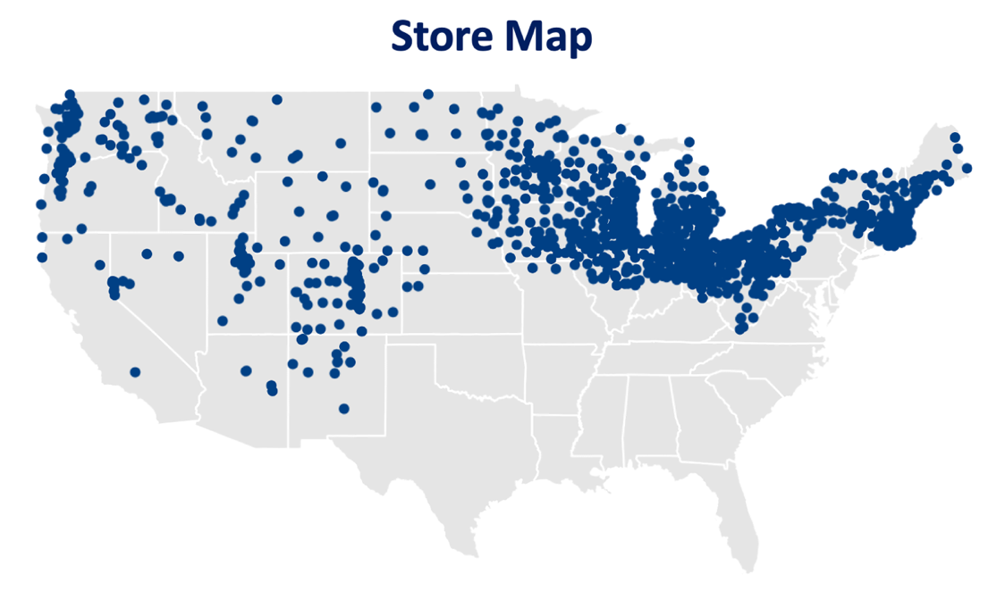
Map of Walmart Stores Included in Dataset
Note: This does not represent all Walmart stores. This is only a subset that was given to us in our dataset.

3.5.1 Seasonality EDA
Our seasonality EDA revealed that the existing category groups named “Seasonal Men’s” and “Seasonal Women’s” include only a small fraction of subcategories, less than 10% of the total. To visualize this, in Figure 2 we created a horizontal bar chart comparing the proportion of subcategories under these seasonal groups versus all other category groups for both men’s and women’s departments.

Figure 2
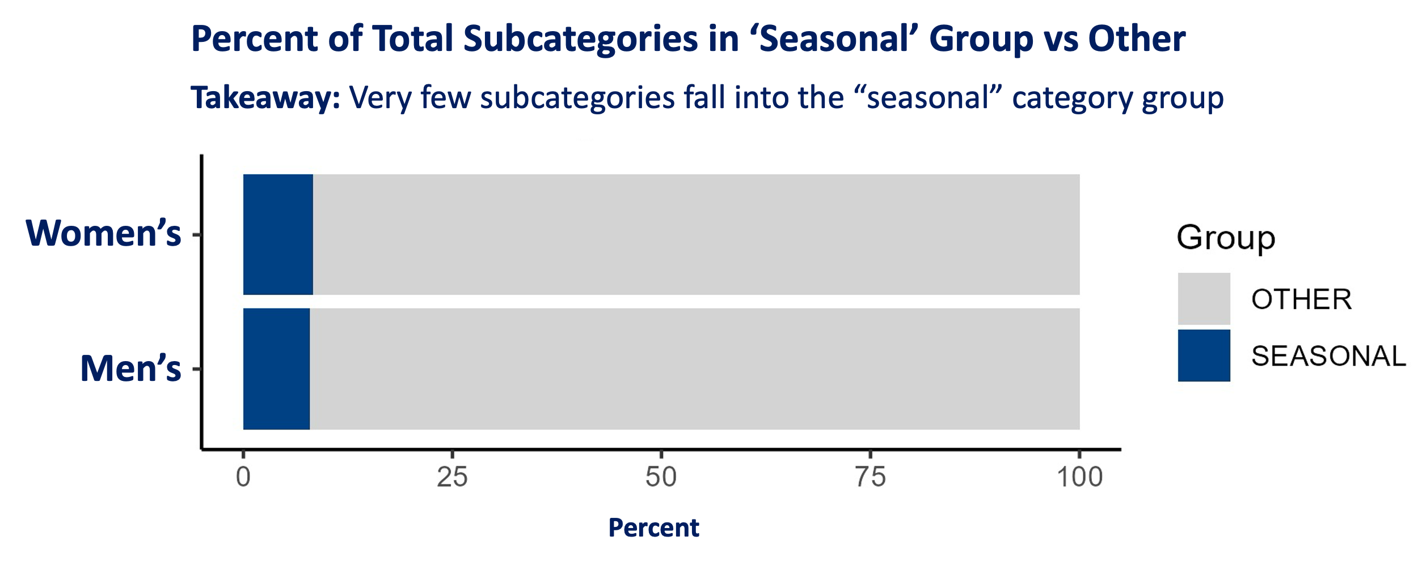
Percent of Total Subcategories in the ‘Seasonal’ Category Groups vs Other
We also examined how often each subcategory appeared in the dataset by calculating the percentage of weeks present per store and plotting these distributions as histograms in Figure 3 and Figure 4. This approach avoided inflating presence when multiple stores carried the same item at different times. The results showed that many subcategories are present for less than half the time, with women’s categories showing wide variation and men’s categories being slightly left-skewed.
Figure 3
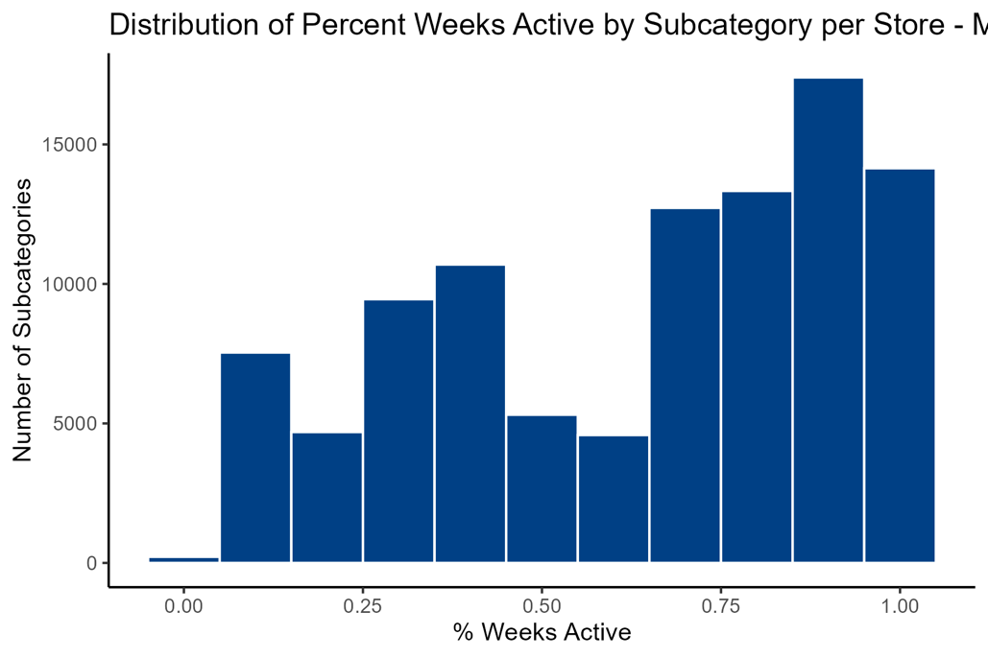
Percent of Total Weeks Men’s Subcategories Appear in Stores

Figure 4
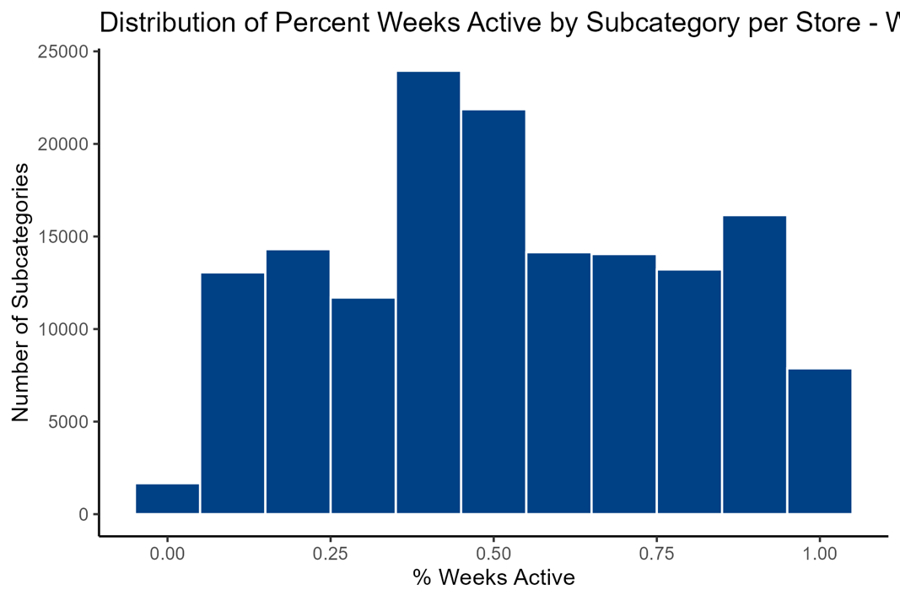
Percent of Total Weeks Women’s Subcategories Appear in Stores

These findings indicated that the current “seasonal” groups only capture obvious items like coats and swimwear, while other potentially seasonal products, such as fleece jackets under activewear, are classified elsewhere. These findings demonstrated that a more robust classification framework was necessary to distinguish seasonal behavior from year-round allocation patterns.

3.5.2 Fixture mix analysis
To start understanding how space is allocated across stores, we first examined total fixture counts by department and region. After merging the cleaned fixture data with the store dimension table, we kept key fields such as fixture type, fixture count, department group, and region, removing records with missing fixture information. We then summarized fixture counts at the regional level for both Men’s and Women’s departments to determine how much physical space each department occupies across the country. Figures 5 and 6 illustrate these aggregated totals. These visuals highlight clear differences across regions in overall fixture presence and give an early indication of how space distribution varies between the two departments.
Figure 5
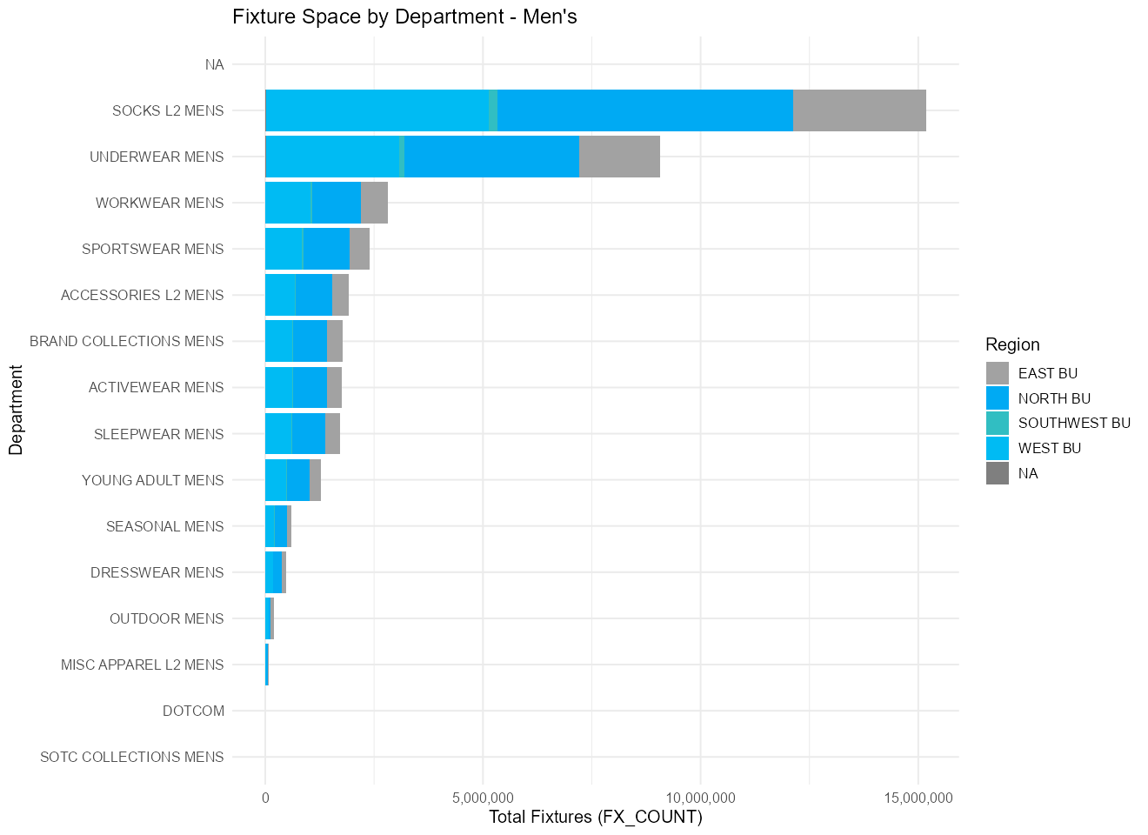
Total fixture count of subcategories by region for men.
Figure 6
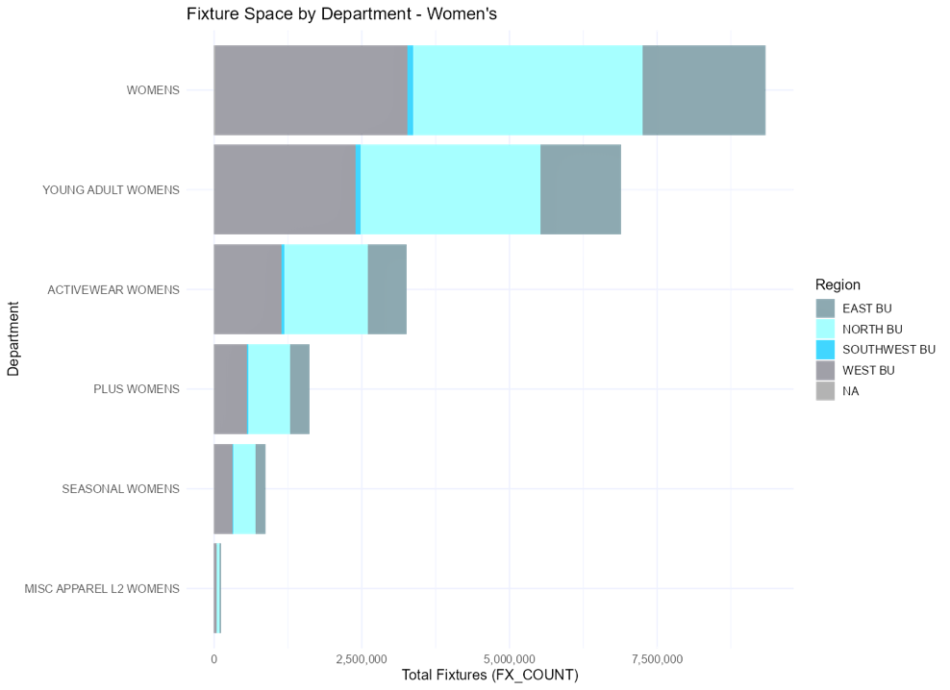
Total fixture count of subcategories by region for women.

In the second part of the analysis, we examined how fixture types are distributed across regions. By grouping fixtures by type and comparing their proportional contributions, we identified which fixture types dominate space usage and how these patterns differ across regions for Men’s and Women’s departments. Figures 7 and 8 show these stacked distributions and reveal distinct fixture usage patterns between the two departments, such as a greater reliance on wall fixtures in Men’s and a more diverse set of fixture types in Women’s. These insights supported later modeling efforts by helping us understand baseline fixture behavior before linking fixture allocation to sales and seasonal demand patterns.
Figure 7
Distribution of Fixture Type by Region for Men
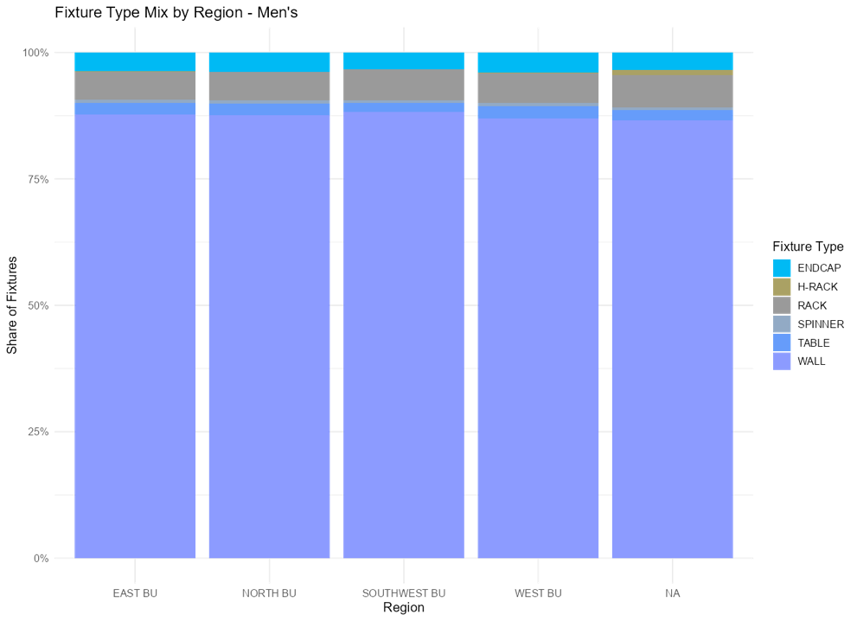

Figure 8
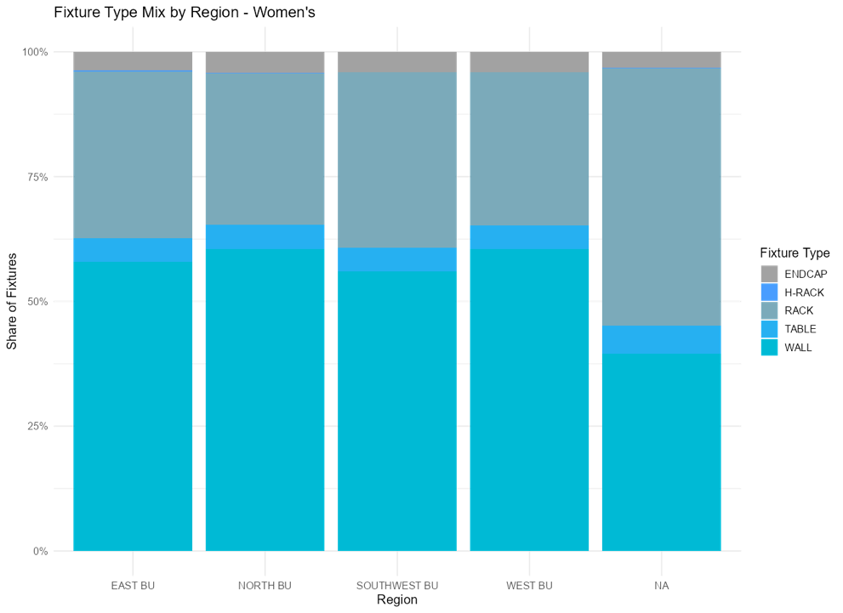
Distribution of Fixture Types by Region for Women

3.5.3 Null Data Analysis and Handling Decisions
Null data analysis and handling decisions were a critical step in exploratory data analysis. To ensure accurate modeling results, minimizing the impact of null data was a priority throughout data preparation. The Walmart dataset was extremely large, particularly in the men’s department, with approximately 22 million rows, so the nulls were extensive as well. While a few different data columns have nulls, the main ones that we focused on were sales and fixture data as these were the most critical variables for classification and optimization modeling. Figures 9 and 10 show the number of null values in every data column. There were numerous data columns but only four of them had any null values present. Department info, item quantity data, sales, and fixture data were the only four columns in our dataset that had null values. Department info and item quantity data nulls were not deleted or manipulated in any way because they lack a use case at this time. The fixture count column was our most critical data. We wanted to find a way to save as much data as possible from this column even when the null values were extensive. Working with our industry partners, we identified a method to recover missing fixture values using mod plan information. Mod plan ID is a column that describes the overall layout of an item or category. The fixture data from a mod plan ID is consistent throughout the mod plan. The nulls in the fixture data were only dropped if there was no mod plan data that could be used to impute new data. With this method, we saved about 2 million rows of data from being dropped. The sales data category was handled a little differently. The group decided we only needed an average sales value for each individual item, so sales data was only dropped if there were less than three instances of price points related to one item. This way we could find an average price point of items with more than three instances of sale.
Figure 9
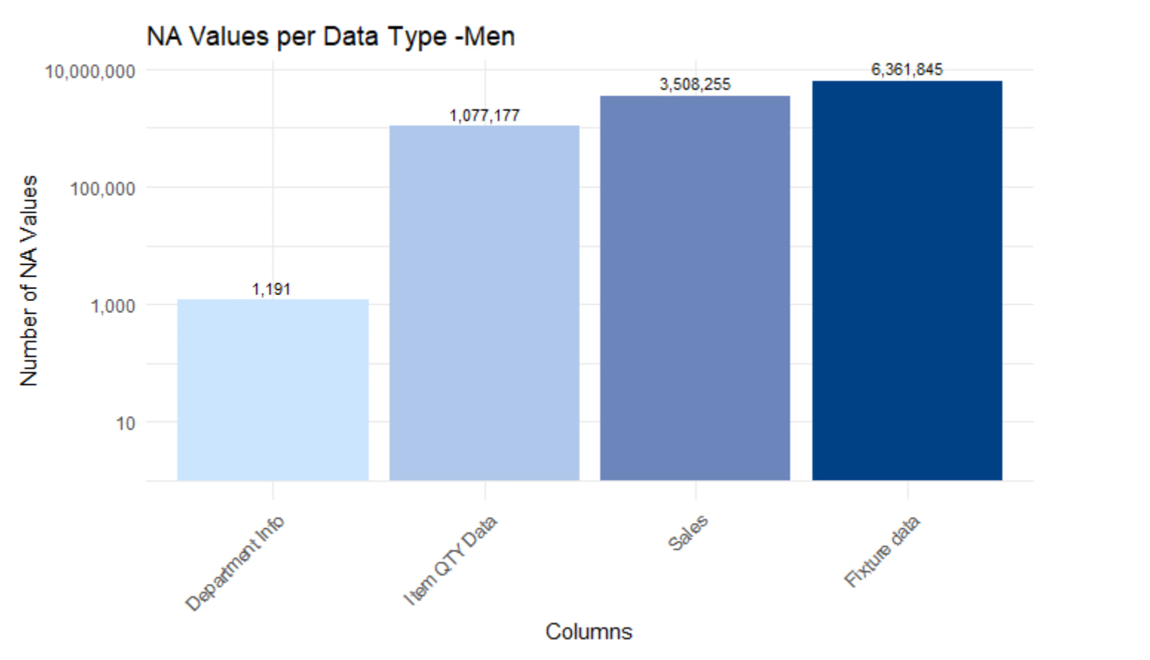
Men’s Data Null count across Data Columns

Figure 10
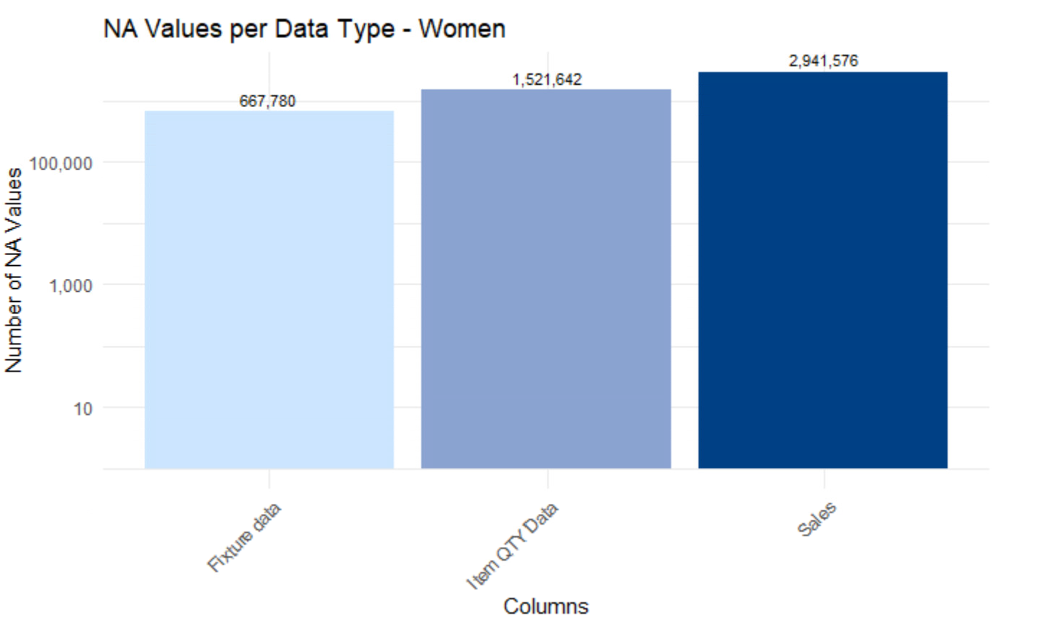
Women’s Data Null count across Data Coulumns

Our industry partners also identified specific time periods where fixture data was missing for extended spans of time due to past Walmart merchandising practices. Look at figure 11 and figure 12. Figures 11 and 12 show how null values were distributed over time across both datasets. The summer of 2024 accounts for most of the null data in our tables. Most of the missing data occurred during summer 2024, which aligned with known operational and merchandising changes discussed by our industry partners. This period reflected a broader structural shift in store planning processes and likely contributed to the spike in missing fixture data.
Figure 11
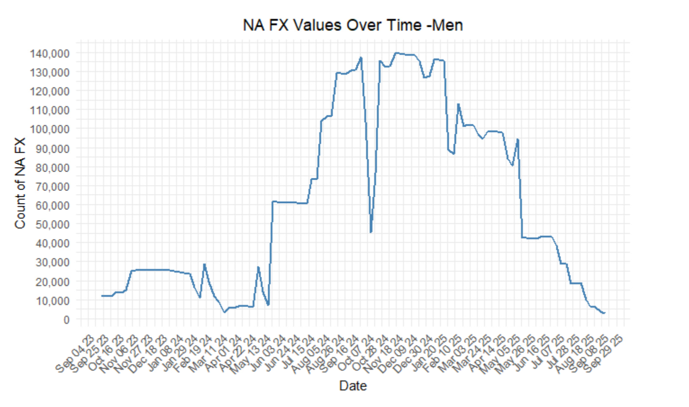
Nulls over time –Men’s Dataset
Figure 12

Nulls over time –Women’s Dataset

3.6 Model Implementation
3.6.1 Subcategory Classification
A major challenge in this project was determining how to distinguish truly seasonal categories from stable, year-round categories in a way that reflected actual fixture allocation behavior. Walmart’s existing category groups, labeled “Seasonal Men’s” and “Seasonal Women’s,” captured only a small portion of subcategories and did not fully reflect how fixture space changed across stores and over time. Because of this, relying solely on existing labels would not provide enough accuracy for optimization.
Our initial approach explored classification at the fineline and mod plan levels using metrics such as sales concentration, frequency of appearance, and allocation consistency. However, these levels of granularity proved too unstable for reliable classification. Finelines experienced high turnover, assortment changes, and inconsistent presence across stores, making it difficult to capture broader fixture strategy. Mod plans improved consistency but still did not align well with the operational decisions being made by merchandising teams.
We ultimately shifted the analysis to the subcategory level, which better reflected how fixture allocation decisions are made in practice. Subcategories provided enough detail to capture meaningful differences in product behavior while remaining stable enough for store-level comparison. This level appeared to align more closely with how modular planning teams evaluate and allocate retail space.
To classify subcategories, we created two key features for every store × subcategory combination across the full weekly time series. The first metric was presence, measured as the proportion of weeks a subcategory was active within a store. This captured how consistently a subcategory occupied fixture space over time. The second metric was volatility, measured using the coefficient of variation (standard deviation divided by mean) of adjusted weekly fixture counts. This captured how much fixture allocation changed when the subcategory was present.
Before calculating these features, fixture counts were adjusted to prevent double-counting shared modular plans. Because multiple finelines can exist within the same mod plan, using raw fixture counts would overstate total allocated space. To correct this, adjusted weekly fixture counts were calculated as:
Adjusted Fixture Count = FX_COUNT × FINELINE_FX_COUNT
where FX_COUNT represents the total number of fixtures assigned to the modular plan and FINELINE_FX_COUNT represents the proportion of those fixtures attributed to a specific fineline. These adjusted values were then aggregated to the store × subcategory × week level for feature generation.
Figure 13 and 14 illustrate the relationship between subcategory presence and fixture volatility across Men’s and Women’s departments. The threshold boundaries shown in the figure were used to separate stable, moderate, and seasonal allocation patterns based on how consistently subcategories occupied fixture space and how much that allocation changed over time.
Figure 13
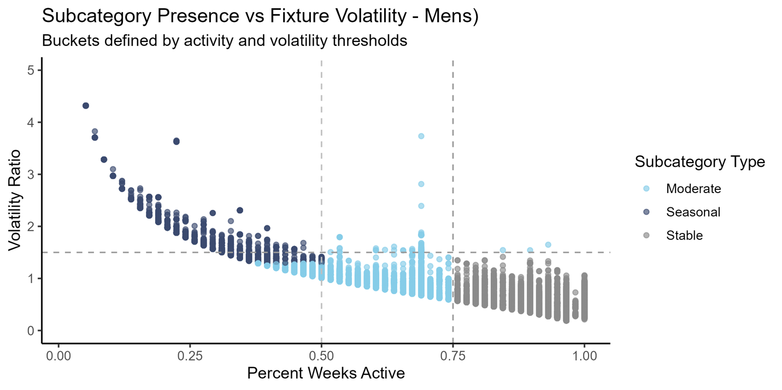
Subcategory Classification – Men’s

Figure 14
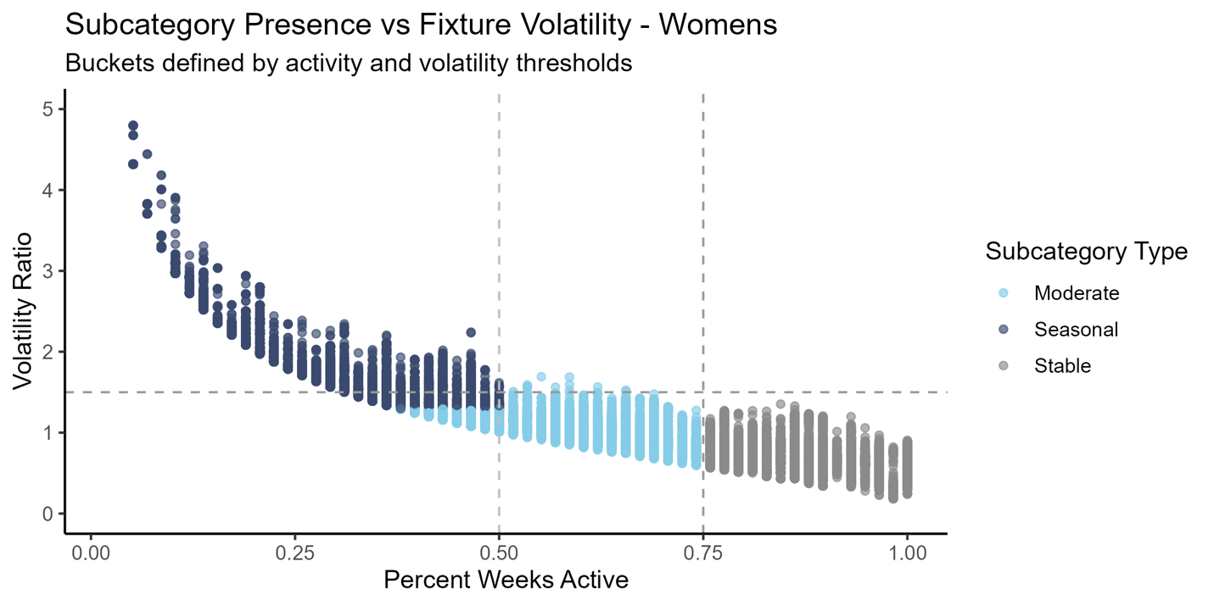
Subcategory Classification – Women’s

Using presence and volatility together allowed us to create an interpretable rule-based classification framework with three allocation groups:
- Stable: Subcategories present for at least 75% of observed weeks
- Seasonal: Subcategories present for 50% or fewer observed weeks and with a volatility ratio greater than or equal to 1.5
- Moderate: All remaining subcategories that did not meet either threshold
Stable categories represent core base space that should remain consistently available even if some fixture variation exists. Seasonal categories reflect intermittent, high-variability allocation patterns driven by weather, promotions, or seasonal demand. Moderate categories capture flexible space between these two extremes.
These classifications were then aggregated into store-level bucket allocation tables that summarized fixture share and average fixture counts by stable, moderate, and seasonal groups. These outputs became direct inputs into the optimization model, allowing fixture allocation decisions to be driven by both seasonality behavior and predicted demand rather than broad category labels alone.
Figure 15 shows an example of bucket-level fixture allocation for an individual store, where average weekly fixture share is summarized across stable, moderate, and seasonal groups. These aggregated outputs provided direct inputs into the optimization model by quantifying how much space was already allocated across each bucket.
Figure 15
Observed Bucket Share by Department in Example Store
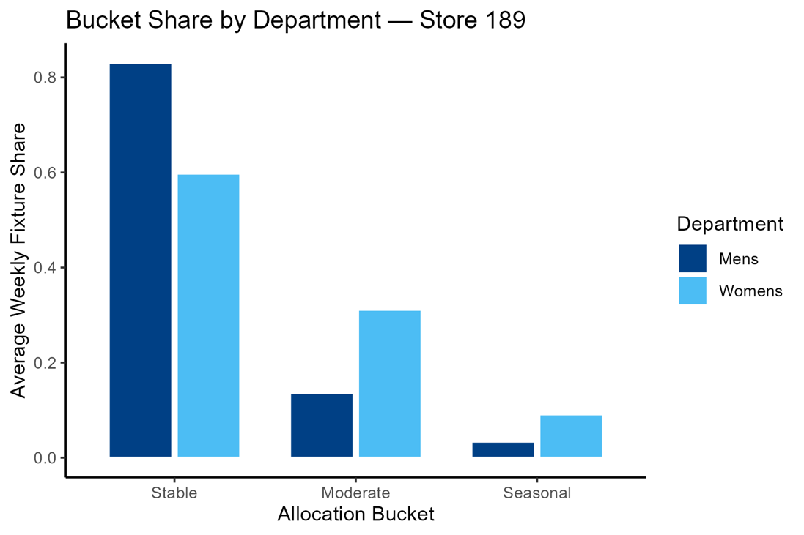
3.6.2 Demand Score Model
A central challenge in this project was that observed sales do not faithfully represent true customer demand. When inventory falls below typical stocking levels, units sold are bound by what is physically available rather than what customers wanted to buy, and any model trained on raw sales would learn this censoring as if it was the real demand pattern. The Demand Score Model addresses this by producing an inventory-adjusted, normalized 0–100 demand score at the store × subcategory × week level. The score serves as the demand-based value coefficient consumed by the optimization model in Section 3.6.3, where stronger expected demand drives higher fixture allocation. Modeling was conducted at the subcategory level for the reasons discussed in Section 3.6.1, and the pipeline is run independently for the men's and women's departments to prevent cross-contamination between department-specific signals.
Before any modeling, a per-(store, subcategory) inventory baseline is established as the 75th percentile of imputed weekly on-hand inventory. Each week is then assigned an in-stock ratio relative to this baseline, and weeks with an in-stock ratio below 0.30 are flagged as inventory-constrained. For these constrained weeks, observed unit sales are scaled upward by the inverse of the in-stock ratio to estimate what demand would have been under healthy stock. The multiplier is capped at 2.0 to keep the adjusted target within plausible bounds and avoid training the model against weeks of fabricated demand. The resulting unconstrained unit’s series replaces raw sales as the model's training target, and a binary flag is preserved on rows where inventory was missing entirely, so the model can distinguish observed health from imputed health.

Figure 16
Math of unconstrained demand score
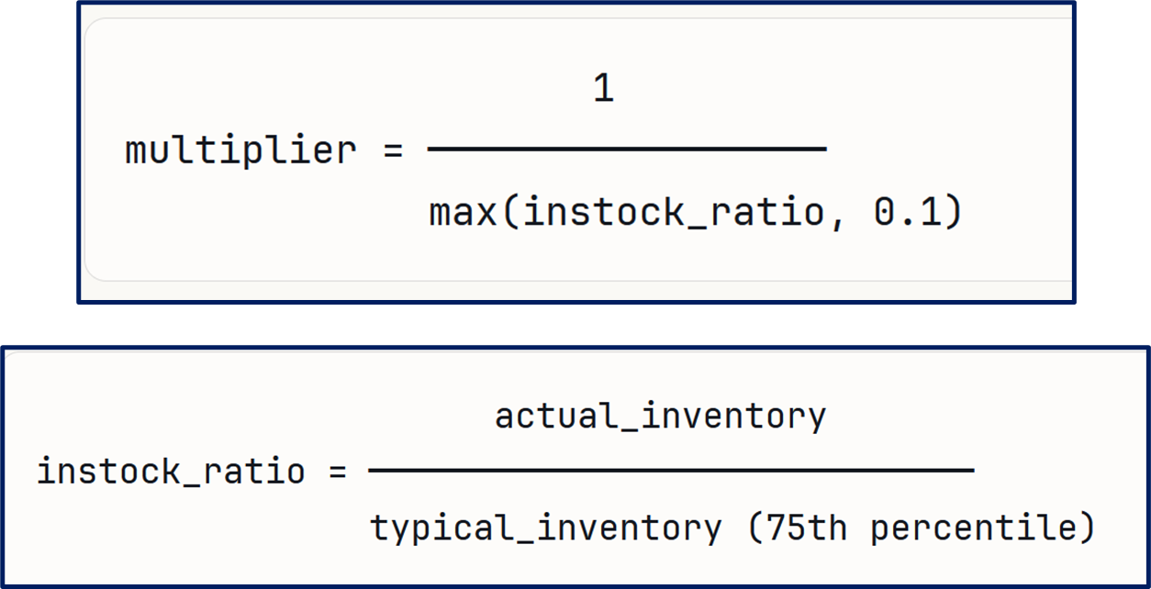

The model is a LightGBM gradient-boosted regression trained on twenty engineered features spanning four families. LightGBM was selected for its ability to handle a heterogeneous feature mix at scale, its native support for missing values, and its inspectable feature importance, which matters in a production handoff. The dataset is partitioned on a strictly time-based split — the earliest 80% of weeks form the training set and the most recent 20% form a held-out validation set — with early stopping on validation RMSE preventing overfitting. The feature set is summarized in Figure 17.
Figure 17
Demand Score Model Feature Set
Family | Feature | Description
Temporal | year, week_of_year | Calendar year and week-of-year (1–52) parsed from WM_YR_WK
Temporal | week_sin, week_cos | Sine and cosine encoding of week-of-year on a 52-week cycle, allowing the model to treat the calendar as a continuous loop rather than a discrete index
Lag | lag_1_units – lag_4_units | Unconstrained units in each of the four immediately preceding weeks, computed within store-subcategory groups
Rolling | roll_avg_4wk, roll_avg_8wk, roll_avg_13wk | Right-aligned rolling means at one-month, two-month, and one-quarter horizons
Rolling | roll_sd_4wk | Four-week rolling standard deviation as a recent-volatility signal
Year-over-Year | yoy_units, yoy_ratio | Unconstrained units 52 weeks prior, and the current week's units divided by that lag
Cross-sectional | subcat_week_avg | Mean unconstrained units for the subcategory across all stores in this week-of-year (captures category-wide seasonal patterns)
Cross-sectional | subcat_overall_avg | Long-run mean for the subcategory (captures category-level scale)
Cross-sectional | store_week_avg | Mean for the store across all subcategories in this week-of-year (captures store-level rhythms)
Inventory | instock_ratio | Current week's inventory ratio (0–1.5)
Inventory | avg_instock_ratio | Long-run average inventory ratio for the store-subcategory pair
Inventory | pct_constrained | Share of weeks the store-subcategory pair has been inventory-constrained, signaling historical reliability of observations

Once trained, the model produces a unit-level prediction across all rows. These predictions are min-max normalized to a 0–100 scale within each subcategory, so that a score of 80 has a consistent interpretation across product groupings whose absolute volumes differ by orders of magnitude: the row sits in the upper end of that subcategory's own demand distribution. Subcategory-level normalization is the deliberate choice over a global normalization because the optimization model in Section 3.6.3 cares about which weeks and which stores have higher relative demand for a given subcategory, not about absolute unit counts. The unnormalized prediction is also retained in the output as demand_score_raw for cases where magnitude comparisons across subcategories are needed.
Figure 18
Demand score distribution by subcategory
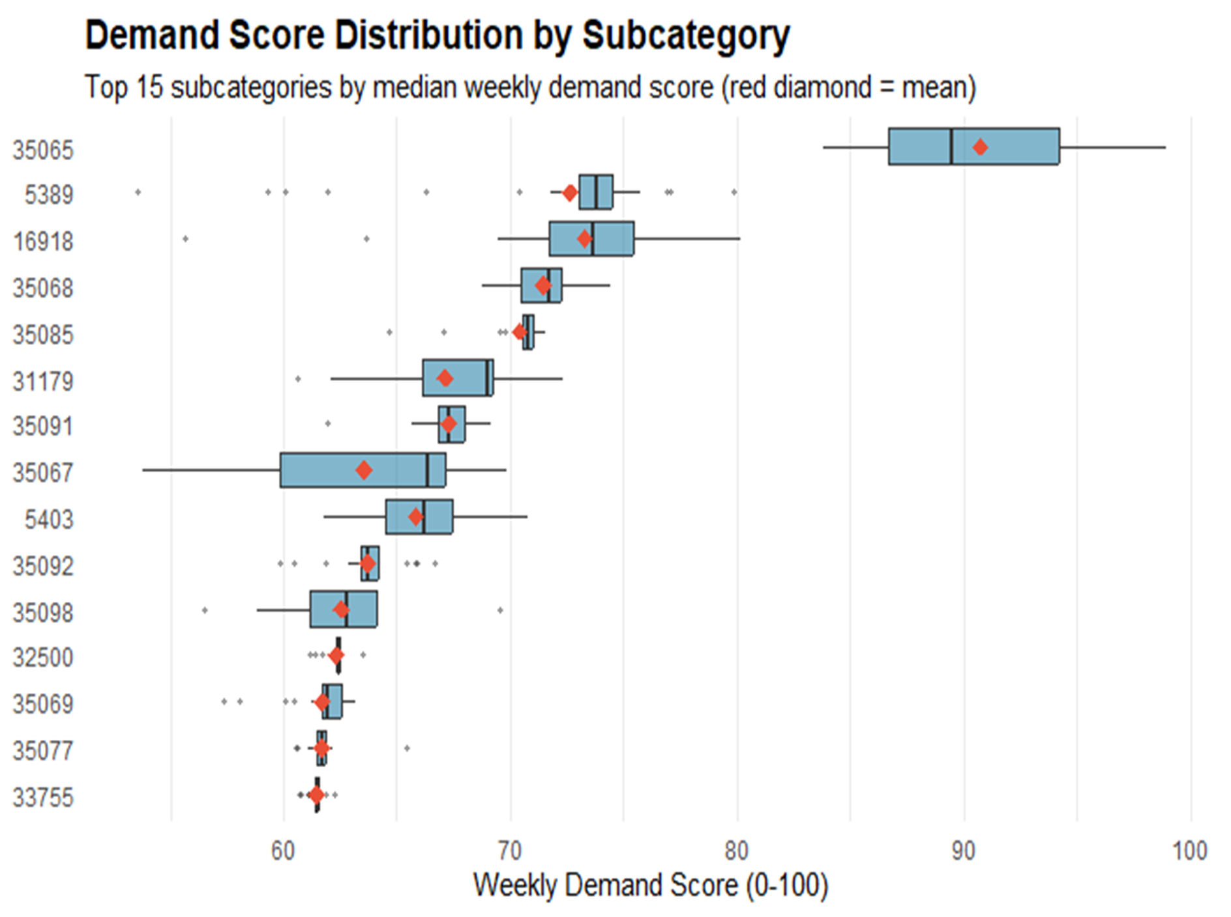
The final output is a tidy file at the store × subcategory × week grain containing the normalized demand score, the raw prediction, the observed and unconstrained unit estimates, and the inventory health diagnostics for each row. This file is consumed directly by the optimization model as the v coefficient in its objective function, allowing fixture allocation decisions to respond to weekly demand variation while remaining grounded in inventory-corrected history rather than censored sales.
3.6.3 Optimization Model
To allocate apparel fixture space to balance structural stability and short-term demand responsiveness, we formulated a weekly optimization model at the store × subcategory × week level. The model determines how much fixture space to assign to each apparel subcategory using two types of space: stable and flexible.
Stable fixture space represents a structurally persistent allocation derived from low-volatility fixture patterns, while flexible fixture space represents the portion of space that can be adjusted more dynamically in response to weekly demand conditions.
- Decision Variables
For each store s, subcategory k, and week t, we define:
- $x_{skt}^{stable}$: stable fixture space allocated to subcategory k
- $x_{skt}^{flex}$ : flexible fixture space allocated to subcategory k
These variables are continuous and nonnegative.
- Objective Function
The objective is to maximize total demand-weighted fixture allocation across subcategories:
$$\max{\sum_{k}^{ }{v_{skt}\left(x_{skt}^{stable}+x_{skt}^{flex}\right)}}$$
where v is the demand-based value coefficient for store s, subcategory k, and week t. In practice, this coefficient is derived from the weekly demand score.
This objective encourages the model to allocate more space to subcategories with stronger expected demand while still respecting store-level capacity limits.
- Constraints
  - Stable capacity constraint
The total amount of stable fixture space assigned in a store-week cannot exceed the store’s available stable fixture capacity:
$$\sum_{k}^{ }{x_{skt}^{stable}}≤ StableCap_{s}$$
  - Flexible capacity constraint
Similarly, the total flexible fixture allocation cannot exceed available flexible capacity:
$$\sum_{k}^{ }{x_{skt}^{flex}}≤ FlexCap_{s}$$
  - Subcategory allocation upper bound
Each subcategory has a maximum feasible allocation based on historical fixture usage statistics:
$$x_{skt}^{stable}+ x_{skt}^{flex}≤ UB_{sk}$$
This prevents the model from assigning unrealistically large fixture counts to a subcategory.
  - Stable allocation eligibility
Not all subcategories are eligible for stable allocation. To enforce this, stable assignment is bounded by a subcategory-specific stable upper bound:
$$x_{skt}^{stable}≤ StableUB_{sk}$$
This ensures that only historically stable subcategories can receive stable fixture space.
Nonnegativity
All allocation variables must be nonnegative:
$$x_{skt}^{stable}, x_{skt}^{flex}≥0$$

3.6.d Model Interpretation
This optimization framework captures two key operational realities. First, some portions of apparel space remain structurally stable over time. Second, another portion of space can flex in response to weekly changes in demand. By combining demand scores with stable/flexible capacity constraints, the model provides a practical fixture allocation recommendation that is both data-driven and operationally realistic.

3.7 Tools and Technologies
The tools of this project have been an obstacle rather than an asset. This is not considered entirely negative in our opinion. Our technical difficulties adjusting to Walmart procedures serve as a lesson in real-world business standards. At the beginning of this project, Walmart gave us work laptops so we could access the Walmart network from campus. This was their security standard and mandatory for the continuation of the project. Before we could set to work on these laptops, a few troubleshooting meetings were held at the Walmart campus. Our group gained access to the full scope of Walmart laptops before most other groups; however, complications with these devices were minor but consistent.
One of the main obstacles was the VDI or virtual desktop interface. Walmart protocols instructed us to not only connect to the Walmart network via VPN but also load into a VDI environment to do any work. The VDI took a while to boot up, and there were often hiccups in connecting to the VPN or VDI. Scheduled maintenance of either software halted progress. Luckily, our industry partners were very responsive, offering help and solutions whenever issues arose.
Our industry partners had us use Microsoft SharePoint to keep track of files throughout the project. One outage caused issues with due dates, but otherwise SharePoint served as a valuable organizational tool. R and RStudio were the preferred coding environments for our Walmart partners. Installing them on Walmart laptops was complicated since only packages approved by Walmart staff could be used. To their credit, the approved list was extensive, and any additional packages could be requested and added to the zip file. Our team initially struggled returning to R since Python has been our platform of choice for EDA, but after some research, we quickly adapted.
One thing Python exceeds at that R Studio does not is handling large datasets. The biggest Walmart file had 22 million rows, which R struggled to compute in a CSV. In addition to R limitations, the physical hardware of Walmart laptops created a bottleneck for heavier computations. These technical difficulties imposed by Walmart procedures created an interesting problem-solving opportunity. Our team found clever ways around these limitations, including segmenting workbooks, breaking up the dataset, and using clever joins. The technical contributions were a small headache; however, we believe overall they proved an insightful challenge.

Optimization Results & Insights

4.1 Capacity Utilization

The optimization model reveals clear differences in utilization between stable and flexible fixture space. Flexible fixtures consistently achieve higher utilization rates than stable fixtures across both departments, indicating that demand-responsive space is more efficiently used, while stable space provides baseline coverage for core categories.

As shown in Figure 19, flexible fixture utilization exceeds stable utilization in both men’s and women’s departments, reinforcing the importance of maintaining adaptable fixture capacity.

Notably, total utilization is not 100%, as the model prioritizes value maximization rather than full capacity usage. Once high-demand categories are satisfied, allocating additional space would reduce overall efficiency. space is more efficiently used, while stable space provides baseline coverage for core categories.
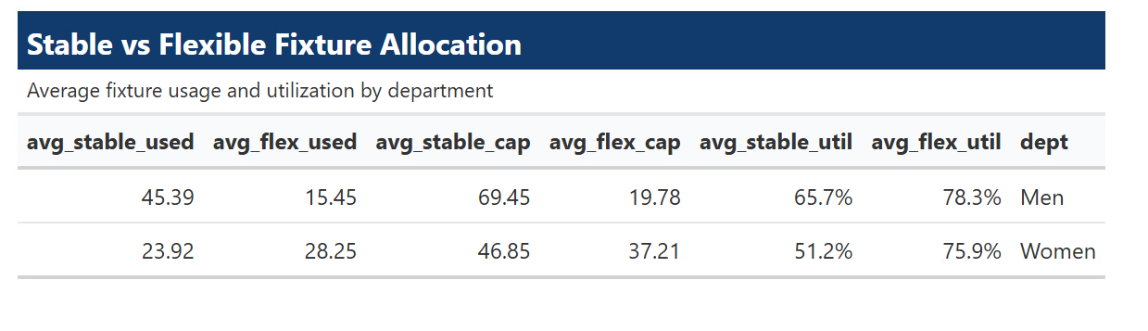
Figure 19
Stable vs. Flexible Fixture Utilization by Department

4.2 Allocation Concentration

Fixture allocation is highly concentrated among a small number of subcategories. A limited set of high-demand categories consistently receives most of the allocated space.

As illustrated in Figure 20, this distribution follows a Pareto-like pattern, where a small subset of subcategories accounts for the majority of fixture allocation. This concentration reflects the model’s prioritization of categories with the highest demand signals.

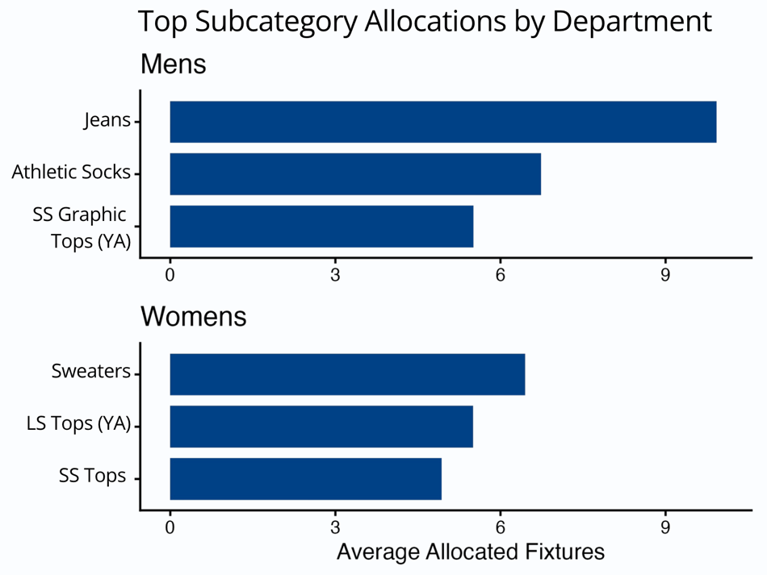
Figure 20
Stable vs. Flexible Fixture Utilization by Department

4.3 Department-Level Differences

Significant structural differences exist between departments, as shown in Figure 21.

Men’s departments exhibit more stable allocation patterns, with space distributed across a wider range of subcategories. In contrast, women’s departments show more concentrated allocation and greater reliance on flexible space, reflecting higher demand variability and more trend-driven behavior.

These findings suggest that allocation strategies should be tailored by department rather than standardized across all apparel categories.

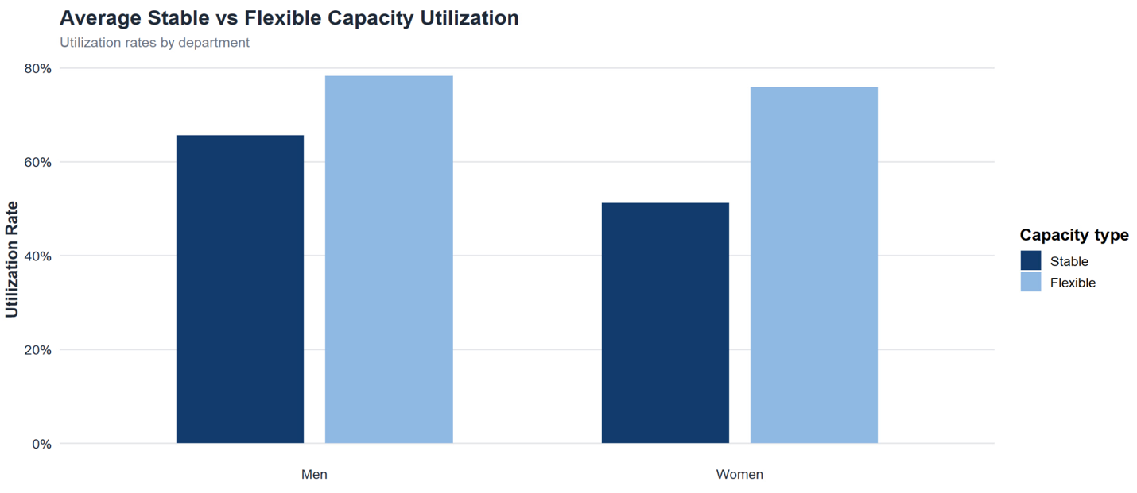
Figure 21
Stable vs. Flexible Fixture Utilization by Department

Top Subcategory Allocations

The model consistently prioritizes high-performing subcategories. These categories receive a disproportionate share of fixture space due to their strong demand signals.
Figure 20 highlights the top allocated subcategories, showing that a small number of categories dominate fixture allocation. This confirms that the optimization framework aligns with expected merchandising priorities while still allowing flexibility for emerging trends.

4.5 Example Store-Week Allocation

The model produces allocation outputs at the store-week level, demonstrating how space is distributed across subcategories in a realistic retail setting.

An example output is shown in Figure 22, illustrating how fixture space is allocated across subcategories while prioritizing high-demand categories. The resulting allocation patterns are both interpretable and operationally feasible, supporting practical implementation in a retail environment.

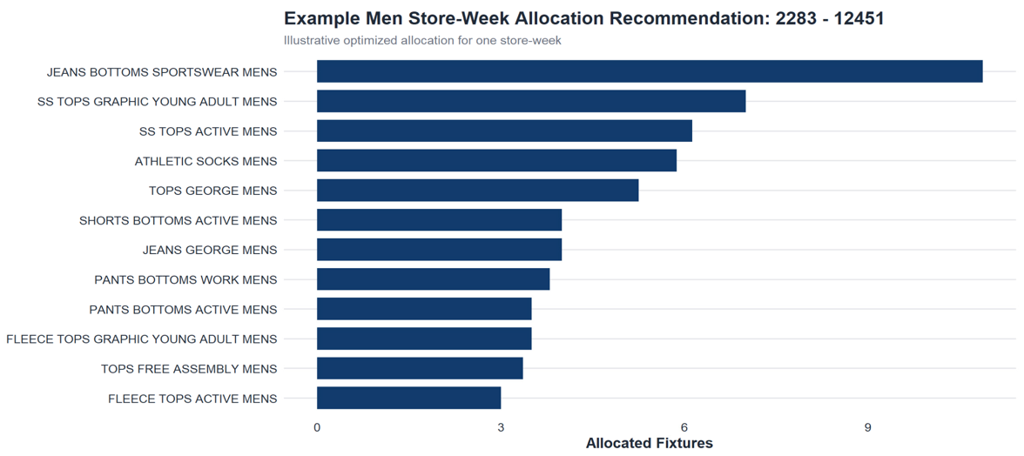
Figure 22
Example Store-Week Fixture Allocation Output

While the model effectively prioritizes high-demand subcategories, it treats each subcategory independently. In practice, customer purchasing behavior often involves substitution between similar items, suggesting an opportunity to further refine allocation decisions by incorporating relationships between subcategories.

Discussion
The results of the optimization model highlight several important insights about how fixture space should be allocated in apparel departments. One of the most notable findings is that maximizing fixture utilization does not necessarily produce optimal outcomes. Instead, the model prioritizes allocating space to high-demand subcategories, even if that results in some unused capacity. This indicates that efficiency should be evaluated based on value generated rather than total space utilization.
The distinction between stable and flexible fixture space plays a critical role in allocation behavior. Stable space provides consistent coverage for core categories that maintain steady demand throughout the year, while flexible space allows the model to respond dynamically to shifts in seasonal demand. The higher utilization observed in flexible fixtures suggests that demand-responsive allocation is more effective for capturing short-term opportunities.
Department-level differences further reinforce the need for tailored allocation strategies. Men’s departments exhibit more stable allocation patterns, with space distributed across a wider range of subcategories. In contrast, women’s departments show more concentrated allocation and greater reliance on flexible space, reflecting the more trend-driven nature of demand. These differences indicate that a uniform allocation strategy across departments would likely result in inefficiencies.
Overall, the model demonstrates that an effective allocation strategy requires balancing stability and flexibility. By integrating demand signals with operational constraints, the optimization framework produces recommendations that are both practical and aligned with real-world merchandising behavior.

Business Impact & Recommendations

Business Impact
This project provides a scalable, data-driven framework for improving fixture space allocation across Walmart’s fashion departments. By replacing intuition-based decision-making with optimization-driven recommendations, the model enables more consistent and efficient use of retail space.
Key impacts include:
- Improved alignment between fixture allocation and customer demand
- Increased efficiency of flexible fixture space
- Better support for modular planning and assortment decisions
- Reduced reliance on inconsistent or incomplete seasonal category labels

Recommendations
Based on the model results, we recommend the following:
- Prioritize high-demand subcategories when allocating fixture space to maximize productivity
- Expand the use of flexible fixtures where operationally feasible, as they consistently show higher utilization
- Maintain stable fixture space for core, year-round categories to ensure consistent product availability
- Adopt department-specific allocation strategies, particularly for women’s departments where demand is more volatile
These recommendations support a transition toward a more adaptive, demand-driven merchandising strategy that improves both efficiency and decision-making consistency.

Future Work
If this project were extended, several areas could further improve the model and its applicability:
- Incorporating margin data to optimize for profitability rather than demand alone
- Expanding the model across additional store clusters and regions to improve generalizability
- Integrating real-time or more frequent demand updates for more dynamic allocation adjustments
- Refining fixture-level constraints to incorporate additional operational considerations such as visibility or fixture adjacency
Incorporating Substitution Effects Through Similarity Scoring
A key extension of this project would be to incorporate substitution effects between subcategories using similarity-based modeling. In the current framework, each subcategory is treated independently, meaning the model does not account for how demand may shift between similar products when fixture space is reallocated.
In practice, customers often substitute between comparable items. For example, if fixture space for one subcategory is reduced, demand may shift toward similar subcategories rather than being lost entirely. Capturing this behavior would allow the model to better reflect real-world purchasing patterns.
One approach is to compute a similarity score between subcategories using features such as product attributes, historical co-purchase behavior, price ranges, and category hierarchy. These similarity scores could then be used to estimate substitution relationships, allowing the optimization model to account for demand spillover between related categories.
Incorporating substitution effects would enhance the model’s ability to evaluate trade-offs between subcategories and improve allocation decisions, particularly in highly competitive or overlapping product groups. However, this extension would introduce additional complexity and would need to be carefully designed to maintain model interpretability and scalability.

Retrospective
What Went Well
Throughout the practicum, the team successfully developed a structured, end-to-end framework that progressed from exploratory data analysis to a fully implemented optimization model. Once the final datasets were stabilized, the workflow became more efficient, allowing each team member to take ownership of a core component of the modeling pipeline while still contributing to the overall integration of the project.
The modeling work was effectively divided across the team. Stella led the development of the subcategory classification framework for seasonal tagging, Conrad developed the demand score model using machine learning techniques, and Cody designed and implemented the optimization model. This division of responsibilities allowed each component to be developed with depth and focus, while still integrating into a cohesive final framework.
A key strength of the team was strong communication and cross-training across these components. While each team member developed expertise in their specific area, the team ensured that all members had a clear understanding of how each part of the model functioned and how the components interacted. This collaborative approach improved the integration between classification, demand modeling, and optimization, and ensured that the final model remained consistent, interpretable, and aligned with the project objectives.
Regular communication with industry partners further strengthened the project. Weekly meetings helped validate assumptions, clarify business constraints, and ensure alignment between technical outputs and real-world merchandising practices. This collaboration improved both the practicality and relevance of the final solution.
Overall, the combination of clear ownership, strong communication, and cross-functional understanding enabled the team to deliver a well-integrated and scalable modeling framework.
What Did Not Go Well
Despite the overall success of the project, several challenges impacted efficiency and required adjustments throughout development. One of the most significant issues was data availability and quality. Delays in accessing complete datasets, combined with missing and inconsistent fixture data, required repeated cleaning, restructuring, and validation efforts.
The size and complexity of the dataset also introduced technical challenges. Processing tens of millions of rows created performance limitations, particularly within the constraints of Walmart’s computing environment. This required additional effort to optimize data handling, segment datasets, and adjust workflows to accommodate system limitations.
Another challenge was the initial reliance on existing seasonal category labels, which proved to be incomplete and inconsistent with actual fixture allocation behavior. This required a shift in approach and the development of a custom classification framework, adding complexity to the modeling process.
Finally, the project scope evolved over time, including changes in available data and departmental focus. While the team adapted successfully, these changes required revisiting earlier work and adjusting parts of the overall approach.
How to Address These Issues in the Future
Future projects of this scale would benefit from earlier validation of data quality and availability. Establishing a standardized data pipeline at the beginning of the project, including clear procedures for handling missing and inconsistent data, would reduce the need for repeated rework and improve overall efficiency.
To address computational challenges, future work could incorporate more scalable data processing techniques or optimized data structures better suited for large datasets. This would allow for faster iteration during both exploratory analysis and model development.
In terms of modeling strategy, earlier identification of limitations in existing business labels would allow the team to transition more quickly to custom feature engineering approaches, such as the subcategory classification framework developed in this project. Additionally, extending the model to incorporate relationships between subcategories, such as substitution effects based on similarity scoring, could further improve allocation accuracy and better reflect real-world customer behavior.
Finally, maintaining flexibility in project design is critical when working with real-world data and evolving business requirements. Developing modular workflows that clearly separate data preparation, modeling, and evaluation components would make it easier to adapt to changes without disrupting overall progress.
Overall, these improvements would enhance both the efficiency and robustness of future data-driven optimization projects.

Conclusion
This project developed a data-driven optimization framework for apparel fixture space allocation, addressing the limitations of traditional rule-based merchandising strategies. By combining subcategory-level classification, machine learning-based demand scoring, and a capacity-constrained optimization model, the framework produces allocation recommendations that are both interpretable and operationally realistic.
The results demonstrate that fixture allocation should be driven by demand rather than static rules, with flexible space playing a key role in improving overall utilization. Additionally, differences between men’s and women’s departments highlight the importance of tailoring allocation strategies based on demand behavior rather than applying a uniform approach.
Overall, this work provides a scalable solution that can improve fixture utilization, enhance merchandising decisions, and better align retail space with customer demand. The framework also establishes a strong foundation for future enhancements, including more advanced modeling of customer behavior and substitution effects.

References Cited
Ali, M. K. M., Rabiu, S., & Ismail, M. T. (2025). Analytical inventory management and optimization: Theories, methods and applications. CRC Press. https://doi.org/10.1201/9781003534860
A-Z of retail terminology – glossary and definitions. RETAILBOSS. (2024, May 30). https://retailboss.co/retail-terminology/
Bianchi de Aguiar, M. T. P. B. (2015). The retail shelf space allocation problem: New optimization methods applied to a supermarket chain [Doctoral dissertation, University of Porto]. ProQuest Dissertations Publishing.
Düsterhöft, T., & Hübner, A. (2023). Problems and opportunities of applied optimization models in retail space planning. In A. Ghoniem & B. Maddah (Eds.), Retail space analytics (pp. 161–184). Springer. https://doi.org/10.1007/978-3-031-27058-1_8
Gula, E., Lim, A., & Xu, J. (2021). Retail store layout optimization for maximum product visibility. arXiv preprint arXiv:2105.09299. https://doi.org/10.48550/arXiv.2105.09299
Ishichi, K., Ohmori, S., Ueda, M., & Yoshimoto, K. (2019). Shelf-space allocation model with demand learning. Operations and Supply Chain Management, 12(1), 24–30. https://doi.org/10.31387/oscm0360219
Kandemir, B. (2022). A Methodology for Clustering Items with Seasonal and Non-seasonal Demand Patterns for Inventory Management. Journal of Advanced Research in Natural and Applied Sciences, 8(4), 753-761. https://doi.org/10.28979/jarnas.1112146
Lim, A., Rodrigues, B., & Zhang, X. (2004). Metaheuristics with local search techniques for retail shelf-space optimization. Management Science, 50(1), 117–131. https://doi.org/10.1287/mnsc.1030.0165
Omojola, S. (2025, April 14). Seasonal shifts: Adapt Your Fashion Strategy with data. Woven Insights Blog. https://woveninsights.ai/site-blog/seasonal-shifts-adapt-your-fashion-strategy-with-data/
Schaal, K., & Hübner, A. (2018). When does cross-space elasticity matter in shelf-space planning? Omega, 80, 135–152. https://doi.org/10.1016/j.omega.2017.08.015
Smith, S. A., Agrawal, N., & McIntyre, S. H. (1998). A discrete optimization model for seasonal merchandise planning. Journal of Retailing, 74(2), 193–221. https://doi.org/10.1016/S0022-4359(99)80004-9
Soysal, G. P., & Krishnamurthi, L. (2012). Demand Dynamics in the Seasonal Goods Industry: An Empirical Analysis. Marketing Science, 31(2), 293–316. http://www.jstor.org/stable/41488024
The A-Z of retail terminology: 60 trending retail terms | epos now. (n.d.-a). https://www.eposnow.com/us/resources/the-a-z-of-retail-terminologies-60-trending-retail-terms/

